

**Module Code & Module Title**

FC6W51 Work Related Learning

**Year and Semester**

2018-19 Autumn

**Student Name:** Pranaya Pradhan

**London Met ID:** 1703052

**College ID:** np01cp4a170020

**Supervisor Name:** Nilan Joshi

**Supervisor Position:** Senior Software Executive

**Company Name:** Mercantile Office System Private Limited

**Word Count (Where Required):**

*I confirm that I understand my coursework needs to be submitted online via Google Classroom under the relevant module page before the deadline for my assignment to be accepted and marked. I am fully aware that late submissions will be treated as non-submission and a mark of zero will be awarded.*

# Acknowledgement

I would like to explicit special thanks of gratitude to the Supervisor Mr Nilan Joshi, Senior Software Executive who gave me the golden opportunity to do the intern in Mercantile Office System Pvt. Ltd. which helped the student to enhance knowledge and broaden the skills and came to learn many new things in the process of developing a real world software and also did a lot more research on the books, journal, website, etc. which helped me to improved my researching skills. I am grateful to the supervisor.

Secondly, I would also like to thanks to my seniors who assisted me to complete the intern project on time as they assisted by giving suggestion whenever I was in a problem.

Best Regards,

Pranaya Pradhan

Islington College

17030952

Table of Contents

Acknowledgement 2

Table of Tables 4

Table of Figures 4

1. Introduction 1

1.1. Background of the placement 1

1.2. Structure and role of company 2

1.3. Detail of the specific department I worked in 3

2. Review of Activities 4

2.1. Development of Coffee Shop Management System 4

2.1.1. List of Features 4

2.1.2. Tools Used 5

2.1.3. Testing 6

3. Academic Context 18

4. Abilities Evaluation 19

5. Challenges 20

6. Conclusion 20

# Table of Tables

Table 1 Testing No.1 6

Table 2 Testing No.2. 8

Table 3 Testing No.3 10

Table 4 Testing No.4. 13

Table 5 Testing No.5 16

# Table of Figures

Figure 1 Organization Structure of the Company 2

Figure 2 Testing No.1.a 6

Figure 3 Testing No. 1.b. 7

Figure 4 Testing No.2.a. 8

Figure 5 Testing No.2.b. 9

Figure 6 Testing No.2.c 9

Figure 7 Testing No. 3.a. 10

Figure 8 Testing No.3.b 11

Figure 9 Testing No. 3.c. 12

Figure 10 Testing No.4.a. 13

Figure 11 Testing No.4.b. 14

Figure 12 Testing No. 4.c. 14

Figure 13 Testing No.4.d 15

Figure 14 Testing No.5.a. 16

Figure 15 Testing No.5.b. 17

Figure 16 Testing No.5.c. 17

# I**ntroduction**

## Background of the placement

Mercantile Group of Companies is the largest and respected company in the area of office automation in Nepal. It was established in 1951 A.D. Mercantile Group own three main company under the group. The companies are Mercantile Traders, Mercantile Office System and Mercantile Communications Private Limited. These companies deals in Office Automation, Computer Peripherals, Software and Internet Technology in the field of Information Technology.

Mercantile Office System Private Limited is one of the leading computer company in Nepal. The main aim of the company is customer satisfaction. The company has a software development team of more than 90 plus developers to develop software application. Mercantile Office System is faithful to develop core banking software application to many commercial banks and financial institution. Pumori Banking Software is the banking software of the company which is used by many commercial banks and financial institution The Company has also developed an Etracks which is a web-based application for the company’s international customer in order to control the events of the company (Mercantile Office System Pvt. Ltd, 2019) .

## Structure and role of company

Mercantile Office System is working in developing and maintain software application of different organization. Its office is located in Durbar Marg. There are many department in the organization structure of Mercantile Office System and Mercantile Communication. The list of departments are Software, General Admin and Compliance, Telecom Services, MOS Marketing, Software Services, MOS Accounts and MC Accounts.

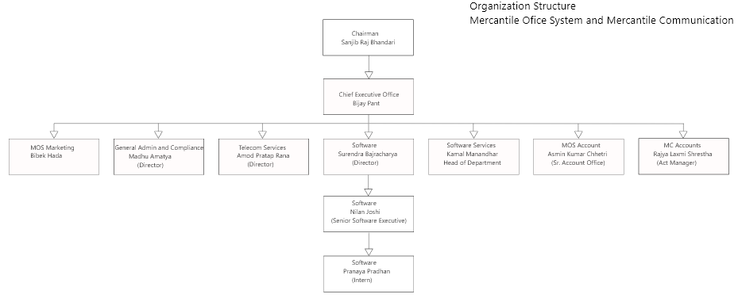

Figure 1 Organization Structure of the Company

## Detail of the specific department I worked in

I got the position of intern in the Software Department of Mercantile Office System. I worked in Software Department of Mercantile Office System. As we know that the Mercantile Office System is one of the largest computer company in Nepal. These companies’ data are kept confidential, so the intern are not allowed to interfere in their work. We are not given the task of the company. But we are given task to work on self-project with the guidance and suggestion of the supervisor. We have to show them during the ending time of internship. Every Week, we have a meeting with the supervisor regarding the progress in the project.

# Review of Activities

## Development of Coffee Shop Management System

In this project, the developer have develop a coffee shop management system. This project is develop with an aim to help coffee owner in order to manage their business. In this application, the owner of the coffee shop can login, add new users, add coffee size and volume and rate as well as the owner can keep the record of overall sale.

### 2.1.1. List of Features

The following are the list of features in the project:   
1. Admin can login into the system.

2. Admin can add new user.

3. User can add size and volume of the coffee.

4. User can add coffee type and price per ml.

5. User can place a coffee order.

### 2.1.2. Tools Used

The following are the tools used in the project:

#### Visual Studio Community 2019

Visual Studio Community 2019 is used in order to create the application and the programming language used will be C#. Visual Studio Community is an integrated development environment (IDE) for C# and other programming languages. Visual Studio Community has the ability to add, resize, and align components, adjust component anchoring, set component auto-resizing behaviour, edit component properties, drag and drop and many other features hence the develop have used these features of Visual Studio Community 2019 in order to successfully complete the project.

#### C#

C# is a widely used programming language expressly designed for use in the distributed environment of the internet. It is the most popular programming language for applications development and is among the most favoured for the internet of things development. The developer used this programming language and will be using GUI in order to build the application because it includes a rich set of widgets.

### Testing

#### Login into the system

|  |  |
| --- | --- |
| **Objective** | To login into the system |
| **Action** | When the user enter the username and password into the system, it will get login. |
| **Expected Result** | The expected result is to login in to the system. |
| **Obtained Result** | The user get login into the system by entering username and password. |
| **Conclusion** | Successful |

Table 1 Testing No.1

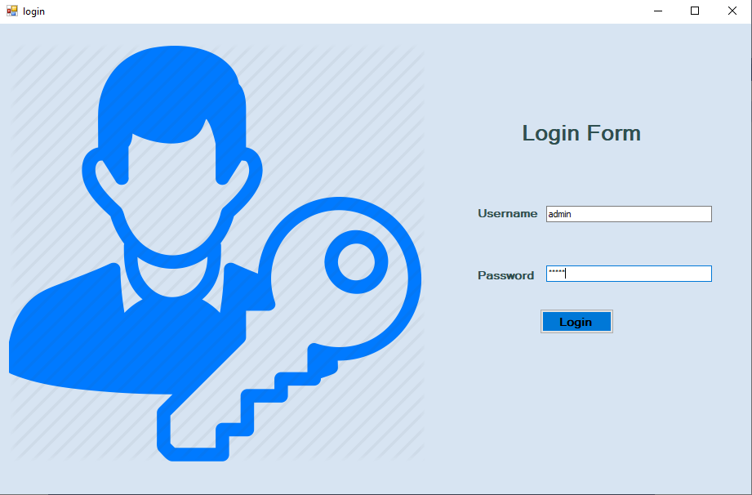

Figure 2 Testing No.1.a

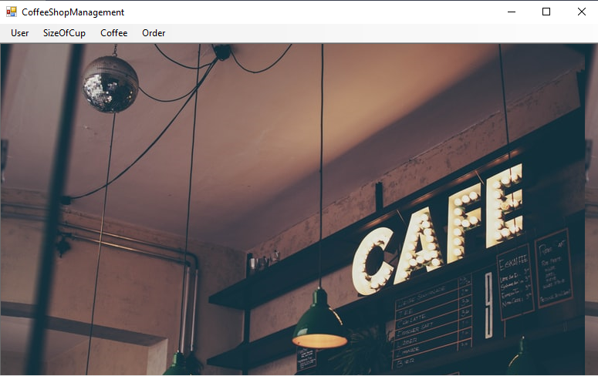

Figure 3 Testing No. 1.b.

#### Adding User

|  |  |
| --- | --- |
| **Objective** | To add new user |
| **Action** | To add new user into the system |
| **Expected Result** | The expected result is to add new user into the system. |
| **Obtained Result** | The user was added into the system. |
| **Conclusion** | Successful |

Table 2 Testing No.2.

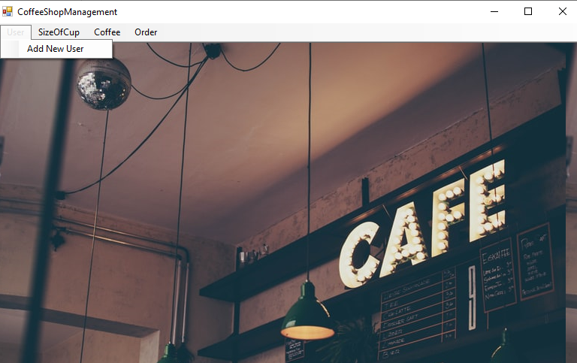

Figure 4 Testing No.2.a.

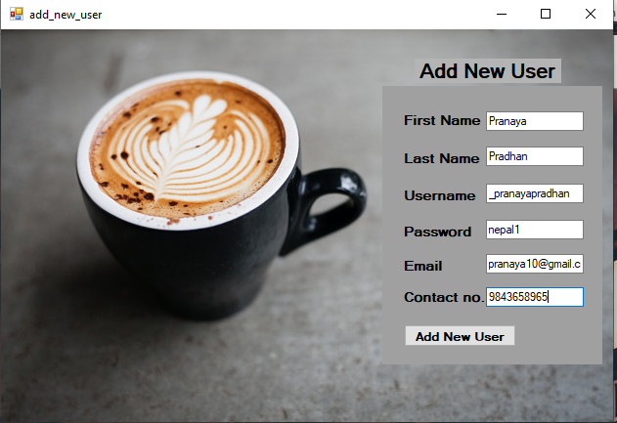

Figure 5 Testing No.2.b.

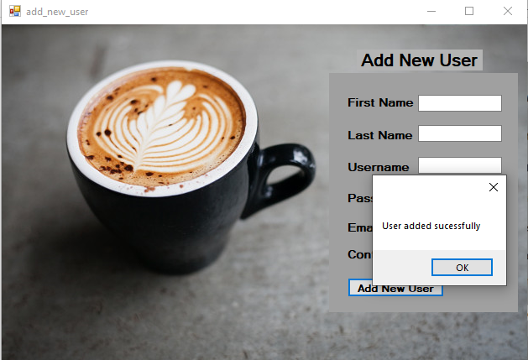

Figure 6 Testing No.2.c

#### Adding size and volume of coffee

|  |  |
| --- | --- |
| **Objective** | To add coffee size and volume |
| **Action** | To add coffee size and volume |
| **Expected Result** | The expected result is to add size and volume of coffee. |
| **Obtained Result** | The obtained result is to add the size and volume of coffee. |
| **Conclusion** | Successful |

Table 3 Testing No.3

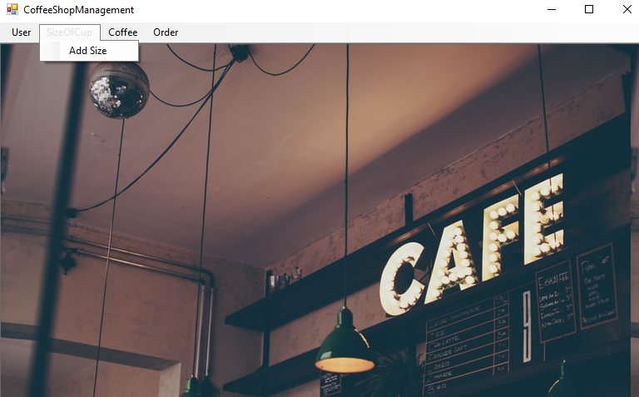

Figure 7 Testing No. 3.a.

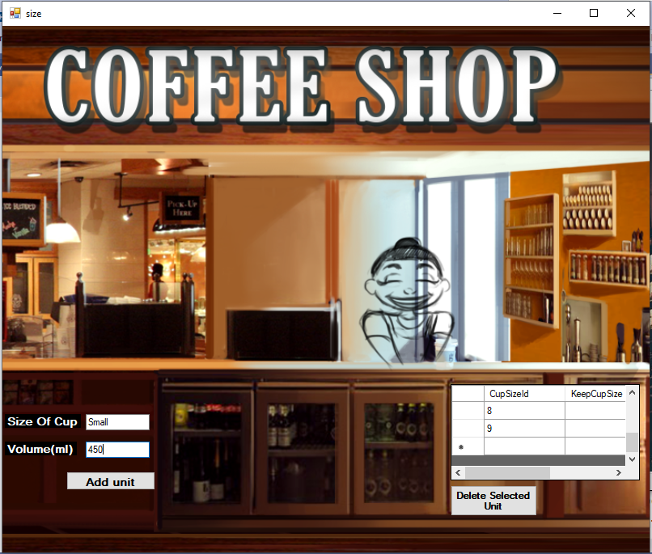

Figure 8 Testing No.3.b

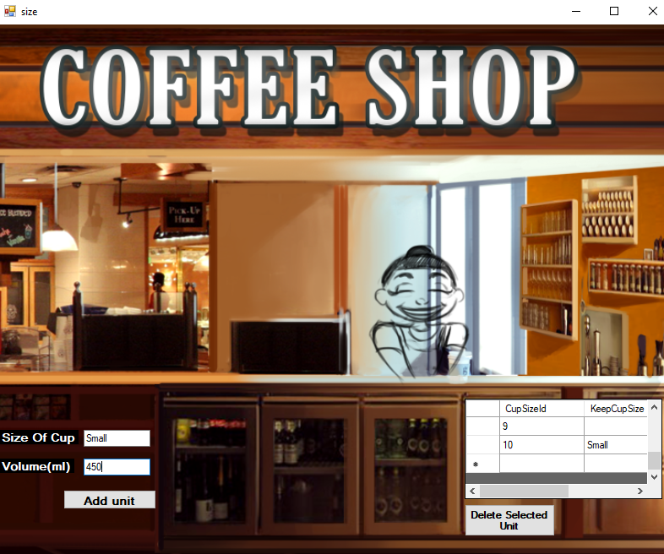

Figure 9 Testing No. 3.c.

#### Adding Coffee Type and Price per ml

|  |  |
| --- | --- |
| **Objective** | To adding coffee type |
| **Action** | To add coffee type and price per ml into the system. |
| **Expected Result** | The expected result is to add coffee type and price per ml into the system. |
| **Obtained Result** | The obtained result was that the coffee type and price per ml was added. |
| **Conclusion** | Successful |

Table 4 Testing No.4.

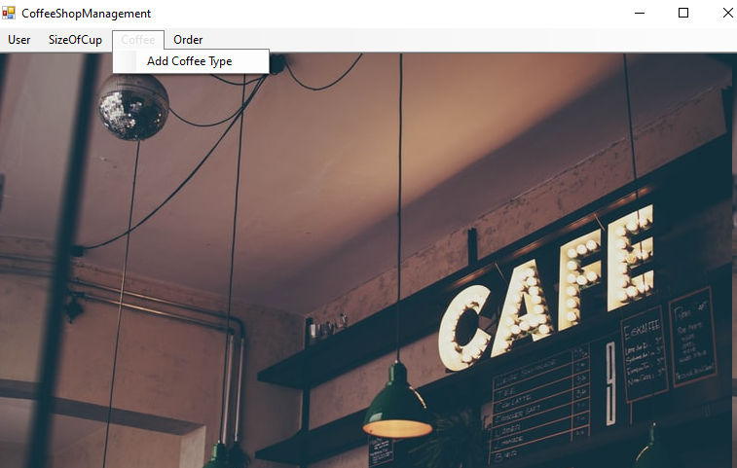

Figure 10 Testing No.4.a.

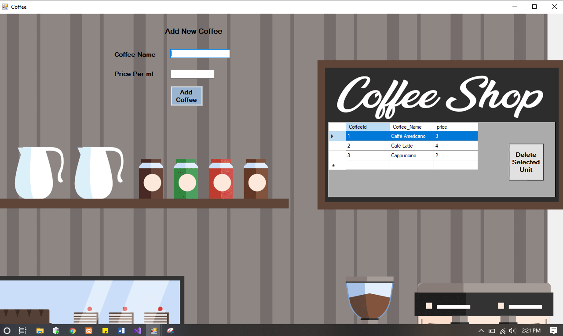

Figure 11 Testing No.4.b.

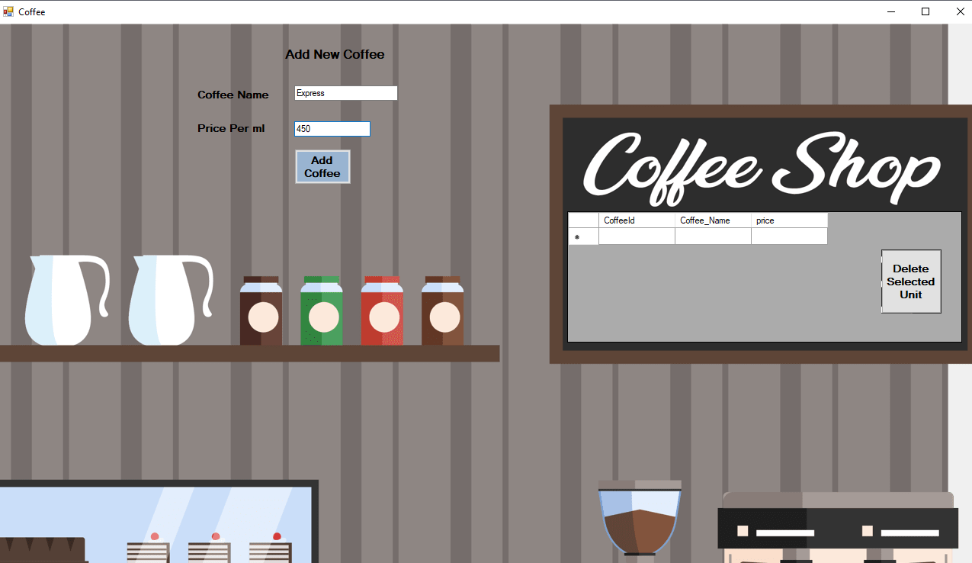

Figure 12 Testing No. 4.c.

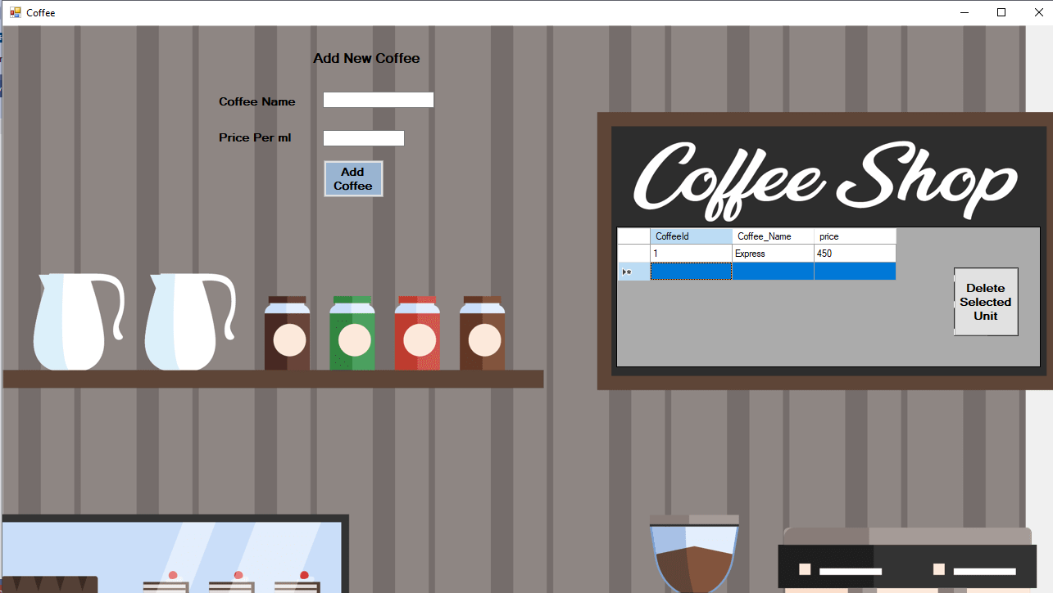

Figure 13 Testing No.4.d

#### Placing an order

|  |  |
| --- | --- |
| **Objective** | To enter order detail and place order. |
| **Action** | To fill the form and place coffee order. |
| **Expected Result** | The expected result is to place a coffee order. |
| **Obtained Result** | The obtained result was the coffee order was placed. |
| **Conclusion** | Successful |

Table 5 Testing No.5

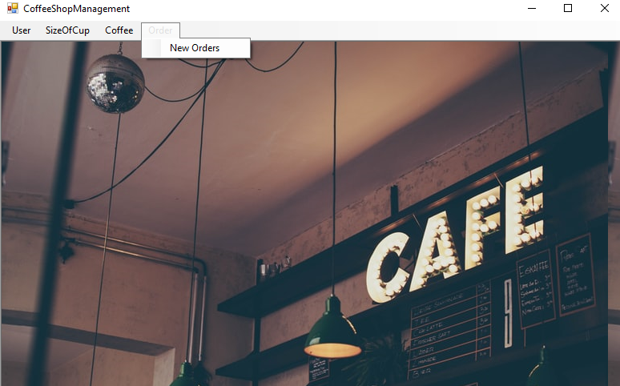

Figure 14 Testing No.5.a.

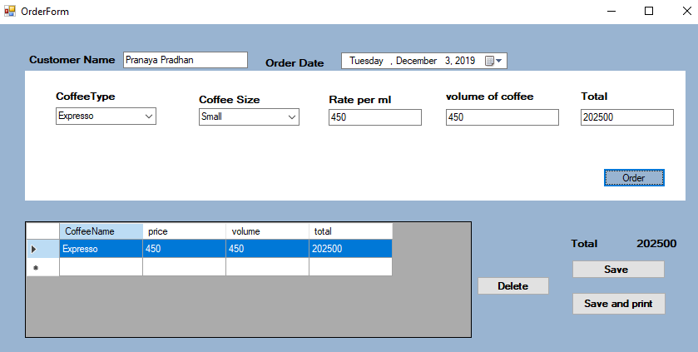

Figure 15 Testing No.5.b.

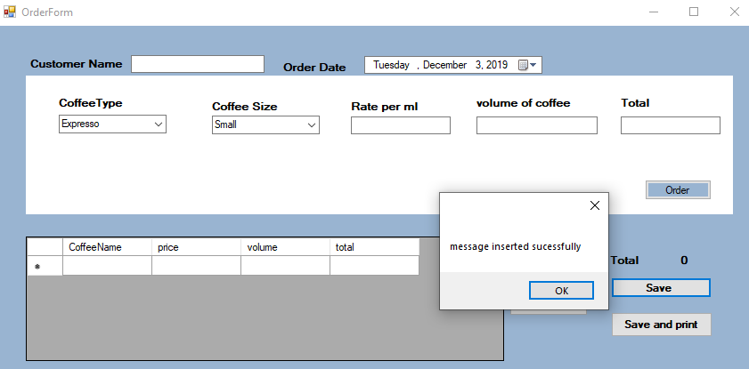

Figure 16 Testing No.5.c.

# Academic Context

In Islington College, we have studied different module in computing both theoretically via lectures and practically via tutorial and lab in order to develop skills for real world practice. Being a BSc. Hons Computing Student, the education about the software and application development helped me to solve problem while doing different project. By studying this module, I was able to gain experience and develop new skills in the information technology field. While studying this course, I have done many individual and group projects and submitted those project in time. The project helps me to get adjust in the internship while working with other interns and seniors in order to complete the given task. The module Emerging Programming Platforms and Technologies helped me to understand the process of building a software and helped to build a software while doing an internship in Mercantile. The module Database also helped me to gain knowledge the process of storing data in database and helps to write different query. Having these knowledge, it helped me to get adjust in the internship.

Previously, we student of Computing had gain only theoretical knowledge. In internship we got an opportunity to implement the theoretical knowledge into practical. During the internship I learned many important things but the most important things that I learned was managing the time to complete different task. I strongly believe that the experience that I obtain this WRL module from the internship would help me in future.

# Abilities Evaluation

While doing internship in Mercantile Office System as an intern it has helped me to improve my learning skills. As an intern, I have develop a learning skills to learn new skills and get started to work on it. I basically started learning the C# during first few days from different online resources and started to build a project. Since my task in the Mercantile was to develop a self-learn project. I had to deal with many bugs which helped me build a debugging skills. Whenever I was in problem I had consult to my supervisor as were as other intern to solve the problem which help to develop my communication skills.

In the Software Department, I build a self-project with the supervision and guidance with my supervisors and colleagues. In my internship, the colleagues and supervisor were very helpful and friendly. Whenever I used to get any problem I used to start consulting with them in order to solve the problem. I had established a good relationship with them. I was a sky personality guy and was not able to communication with strangers. After joining the internship, I developed a professional skills which helped me to communicate with supervisor, colleagues and seniors at Mercantile.

# Challenges

During internship there were many challenges, as I started to work in professional environment for the first time. In the first few week, I was nervous and was not able to perform the task than I was able. There were several challenges in the internship, as I worked in the real-time environment for the first time. I was nervous at the beginning of the internship and could not perform as expected. Initially, I was also bad at communicating and was unable to express things properly. So, it is safe to say that I faced many challenges in the work. During the internship period, it was very difficult for me to manage time. I had to attend college early in the morning and right after the class were over, I had to go home and again get ready for office. Must of the time I didn’t even him time to go back home and eat, so I directly went to the office. I started the internship a little late than the required time, so I had to work on Saturday as well to increase the total number of working days. So, I little to no free time. I also got severely sick during for few weeks and although I couldn’t come to the college for few days, but I somehow managed to come to the office as it was nothing in front of what I was getting in return. There were various challenges, but I knew it was just the beginning and I shouldn't step back in this earlier stage, so I kept my eye on the target, I did the best I could. Some of the most difficult aspects of the task were those situations in which I had no idea of the devices or the problem. I therefore had to research and find the right way to solve the problem. Despite all the challenges, I was supported a lot by the seniors and the supervisor. They were always ready to answer any questions I had about the problem.

# Conclusion

In a nutshell, I learned a lot from this Work-Related Learning module. The time that I spend on the internship has been very educational to me. The WRL module gave me an opportunity to learn and improve myself in many areas. I gained a lot of new experience due to this and I was able to enhance various skills that I was lacking. Communication skills, time management skills, report writing skills, etc. are some of many skills that I learned during this period. This module helped me understand how important it is to log the various activities. Setting the goals and keeping the target deadline myself; helped me to achieve those goals properly. Since this was my first working experience, I have had an incredible experience as well as made many friends and maintained a good relationship with different staff.

# References

Mercantile Office System Pvt. Ltd. (2019) *About Us* [Online]. Available from: <https://www.mospl.com.np/about-us/> [Accessed 3rd December 2019].